Salamander Pumps Launches TankBoost CAT 5 Mains Water Booster System

TankBoost CAT 5 is a cold water booster system, suitable for use on mains water, fitted with type AB backflow protection, making it suitable for commercial use where there is a risk of backflow contamination from fluid Category 5.
This is an all-in-one solution made up of a cold water storage tank, fitted with type AB backflow protection, and an integrated submerged pump. Stored cold water is boosted by this integral submersible pump, delivering up to 3.0 Bar pressure and 80L/min flow.
TankBoost CAT 5 has been designed to meet the requirements of Fluid Category 5 of Water Supply (Water Fittings) Regulations 1999 in England and Wales and the Scottish Water Byelaws which require the installation of a backflow prevention device for protection against a fluid which falls within fluid category 4 or fluid category 5.

Fluid Category 5 Backflow Protection
TankBoost CAT 5 Type AB air gap features an air gap between the inlet and outlet and a weir to ensure that the water in the tank does not flow back into the mains supply.
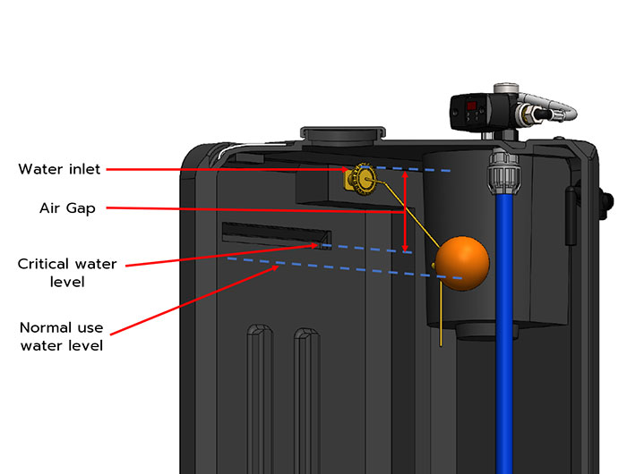

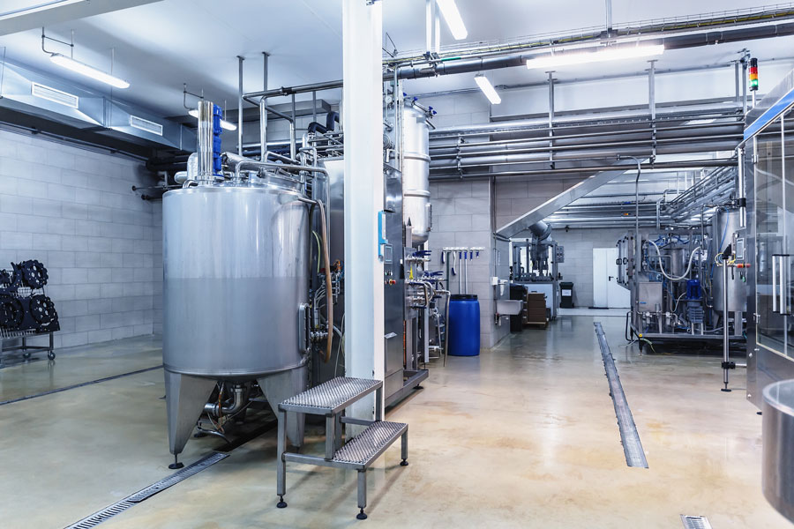
TankBoost CAT 5 Compatibility
Salamander Pumps’ TankBoost CAT 5 range is suitable for commercial entities with a mains-fed system, such as a combination boiler or unvented cylinder.
It’s ideal to be used at abattoirs, dog grooming parlours, bin wash down areas for flats and other entities which carry the highest risk level of the most serious health hazard because of the presence of pathogens and radioactive or very toxic substances (Fluid category 5).
TankBoost CAT 5 is available in for sizes: 100L, 200L, 350L, and 450L. The product range is currently going through the Regulation 4 approval process of both KIWA and WRAS.
TankBoost CAT 5 range is available to order.

